**LiDAR-Based Intruder Detection System**

1. Introduction

The purpose of this project is to design and implement a LiDAR-based system for monitoring and detecting morphological characteristics of mice and other intruders in a mall environment. The system is intended to enhance real-time monitoring, alerting, and data analysis capabilities, ensuring efficient pest and intruder management.

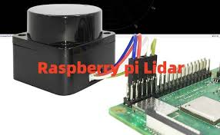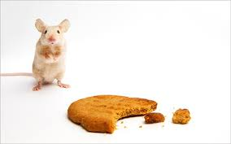

2. Project Requirements

1. LiDAR Data Acquisition: Ability to collect real-time LiDAR data from the ceiling area of the mall.
2. Image Processing and Analysis: Process LiDAR data to identify and classify morphological characteristics of mice and other intruders.
3. Real-Time Monitoring: Monitor and record the time, location, and number of intruders in real time.
4. Alarm Function: Send alarm signals such as sound, light, or mobile phone notifications when a mouse is detected.
5. Data Storage and Report Generation: Store historical inspection data and generate periodic reports for management analysis.

3. Technology Stack

1. LiDAR Sensor: For real-time data acquisition.

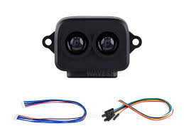

1. Raspberry Pi 4: As the primary edge device for processing and communication.

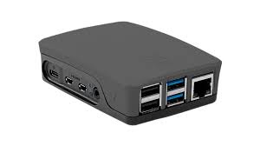

1. MQTT Protocol: For lightweight and efficient messaging between the Raspberry Pi and the server.



1. Server: To handle data storage, analysis, and report generation.

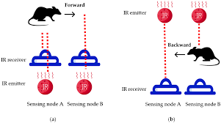

4. Project Progress

The development and implementation of the LiDAR-based system have achieved significant milestones. Below is the status of each requirement:

1. LiDAR Data Acquisition (Pending):

The LiDAR data acquisition from the ceiling area has yet to be implemented. This component requires careful selection and installation of LiDAR hardware, calibration for the mall's ceiling height, and integration with the Raspberry Pi 4. Efforts are ongoing to identify suitable LiDAR sensors that meet the project's accuracy and coverage requirements.

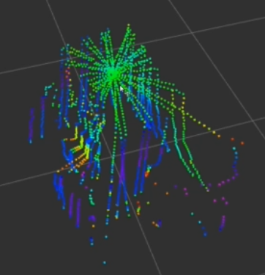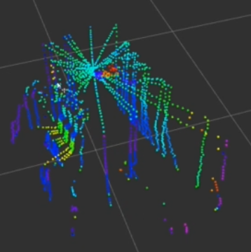

**Picture: map(left) & map with mice(right)**

1. Image Processing and Analysis (Completed):

The system successfully processes LiDAR data on the server to identify and classify morphological characteristics of mice. The detection algorithm demonstrates high accuracy in distinguishing mice based on their size and movement patterns.



1. Real-Time Monitoring (Completed):

The system efficiently monitors and records the time, location, and number of detected mice in real time. The Raspberry Pi 4 transmits raw data via the MQTT protocol to the server, where it is analyzed and presented through a user-friendly dashboard.

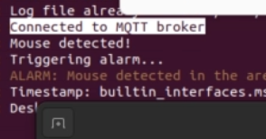

1. Alarm Function (Completed):

The server generates alarm signals, including sound, light signals, and mobile notifications, immediately upon detecting a mouse. This centralized alarm generation ensures consistent and reliable alerts to mall personnel. The MQTT protocol facilitates efficient communication between devices.

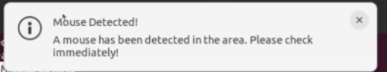

Alarm.mp3 & notification

1. Data Storage and Report Generation (Completed):

Historical inspection data is stored securely on the server. The system automatically generates periodic reports, providing comprehensive insights into mouse activity for management analysis.

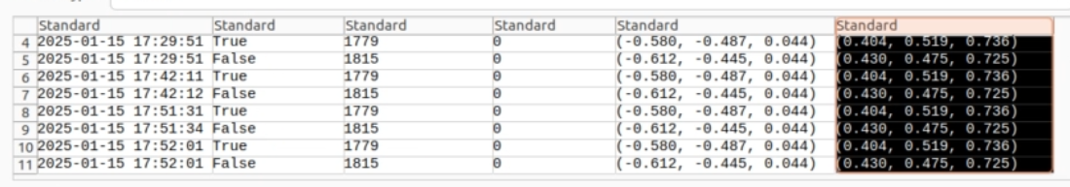

1. Recommendations and Next Steps

To ensure the project meets all client requirements, the following steps are recommended:

* LiDAR Data Acquisition Implementation:
* Procure suitable LiDAR sensors with the necessary range and accuracy.
* Install and calibrate the sensors for optimal performance.
* Integrate the sensors with the Raspberry Pi 4 for data acquisition and processing.

1. Conclusion

The LiDAR-based intruder detection system has successfully achieved most of the project requirements, including real-time monitoring, alarm functionality, image processing, and data storage. The use of MQTT for communication and Raspberry Pi 4 for processing ensures a robust and efficient system. Completing the LiDAR data acquisition component will fully realize the system's potential, ensuring comprehensive coverage and enhanced functionality. Ongoing efforts are focused on implementing this critical feature to deliver a robust and efficient solution for the client.

